**Brooklyn torah gazette**

**For parshas Chaye sarah 5783**

Volume 7, Issue 9 (Whole Number 316) 25 Cheshvon 5783/ November 19, 2022

**Printed L’illuy nishmas Nechama bas R’ Noach, a”h**

For a free subscription, please forward your request to [***keren18@juno.com***](mailto:keren18@juno.com)

Past stories can be found on the website **ShabbosStories.com**

**To Bring Satisfaction to**

**The Creator Yisbarach**

**By Rav Gamliel Rabinovitch**

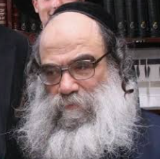

**Rav Gamliel Rabinovitch**

I travel to Meron every Shabbos that we bentch Rosh Chodesh. I have a steady minyan in Meron where they ask me to bentch the month as I have for many years, and it is established that I get it. This year, on the Shabbos that we bentch Cheshvan, I got ready to go to Meron as usual with the rebbetzin.

However, we had an unexpected appointment on Sunday for an important examination for the rebbetzin. I calculated that even if we leave Meron after Shabbos at the earliest possible time, because of traffic we would still arrive in Yerushalayim very late which would be hard for the Rebbetzin, since the appointment was early Sunday morning.

**A Person’s Obligation in this World**

So, I informed the Rebbetzin that we would not be going to Meron this Shabbos. She was speechless since this was our tradition and she would not forego this unless it was for something important like a simcha for the children/grandchildren or something else, but not for something like this… I explained to her that it was not good for her to come back so late and be in the hospital so early, despite that being in Meron for Shabbos meant more to me than I can describe, but after considering all the difficulty and what is a person’s obligation in this world, and what the Creator wants from us at this time, I came to this conclusion and this is what we did.

On Shabbos I went to my minyan in Yerushalayim where I have davened for at least twenty years and to my great surprise, they asked me to bentch Rosh Chodesh. I have never been asked to bentch Rosh Chodesh in this minyan!!!

Occasionally, I would find myself at this minyan on a Shabbos mevarchim, for one reason or another, but they have never asked me to bentch Rosh Chodesh. I went up to bentch Rosh Chodesh and I felt like I received regards from Meron and a smile from the Creator of the world, as if He said, “My son, you made the right decision by not going to Meron!!!”

**Even at the Cost to One’s Wife,**

**Children, Ordinary People or Friends**

Why do I bother to tell my story about Meron?! Because many times I meet young men and even older men, yarei shamayim, who hold onto something specific that without it, they cannot conclude the week, month, or year, and they will not forego this thing even if it is at a cost to the wife, the children, or ordinary people or friends.

The person must know that whoever does the will of Hashem never loses out. Even if it is a tradition of many years, there are times when one must forego this tradition when he senses the will of the Creator. To conclude: when it comes to the will of the Creator, there is no place for nervousness or customs, just do His will and you will never lose out. Baruch Hashem, the examination went well and better than expected, with thanks to the Creator of the world!!! - Moreinu HaRav shlita

*Reprinted from the Parshas Lech Lecha 5782 parsha sheet of Tiv Hakehila*

**Rav Avigdor Miller on**

**Different Folks, Different Strokes**

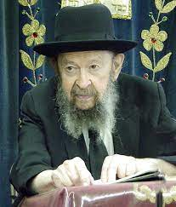

**QUESTION: *When there are differences between different groups among the Jewish People, how are we to know who is right?***

**ANSWER:** Everyone is right. And everyone is wrong. Nobody is perfect in this world. We have to live with the principle of knowing that we ourselves are not altogether right.  And we have to do our best to improve. Although we don’t have to adopt what everybody else does, and everyone should follow the customs and manners of his kehilla in the very best manner, nevertheless, he should know that there are  things to be learned everywhere.

Even though you’re a chossid, when you walk into Telshe Yeshiva, you can learn good things there too. And if a Telshe bochur goes to Williamsburg, he can learn good things there, no question about it. Therefore, everyone should try to steal from others all the good things they can. Instead of going around and saying “Well, I saw in this shteibel that they talk during davening so it’s not so bad.”

Or, “In the other place they daven fast, so I can also daven fast.” So, this person goes around collecting all the wrong things from all the places. No! Go around collecting all the good things from everybody – that’s what they’re there for.

And that’s the person who will succeed. That’s what jealousy is for. Kinah means to be koneh, to acquire, to be jealous of all the good things that you find. “Why is he saying a long shemonah esrei and not me?” “Why does he treat his wife so nicely and I’m so gruff?” “Why does he go out to learn at night and I’m still wasting away?” And everybody should try to steal from everyone else all the good things that they find.

And thus, the first mother, Chava, gave the first child ever born in this world the name Kayin which means to be koneh, to acquire. She wanted him to think about that all the time because that’s our purpose – to acquire all the qualities that find favor in the eyes of Hashem.

Because what Hakodosh Boruch Hu wants of us is shleimus, perfection. Shleimus in knowledge of the Torah, perfection in knowing His ways, perfection in recognizing Him in history and in nature. Perfection in character and self-control and perfection in kindliness to our fellow man. Every form of perfection that’s possible for a person to emulate, to imitate, to steal from all sides, he should do that. Whenever he comes into contact with people, whenever he sees anything good in the world, he should emulate it and decide that he wants to take it for himself.

*Reprinted from the October 23, 2022 email of Toras Avigdor (Tape #781 – April 1990).*

**Thoughts that Count – Part 1**

*And Abraham was old and advanced in age (Gen. 24:1)*

The phrase that the Torah uses for "advanced in age" is literally translated to mean "advanced in days." Every Jew has a mission to accomplish in this world. Often a person looks back and realizes that he missed opportunities or wasted time. Thus, "advanced in days" teaches us that Abraham was able to account for each day and recall what he accomplished every day of his life. *(Zohar)*

*Reprinted from the Parshat Chayei Sarah 5758/1998 edition of L’Chaim. Adapted from Vedibarta Bam by Rabbi Moshe Bogomilsky*

**The Legacy of Abraham’s Greatness –**

**A Zakein Combining the Virtues of**

**“Old” and “Endowed with Days”**

**From the Talks of the Lubavitcher Rebbe**

**Rabbi Menachem Mendel Schneerson, Zt”l**

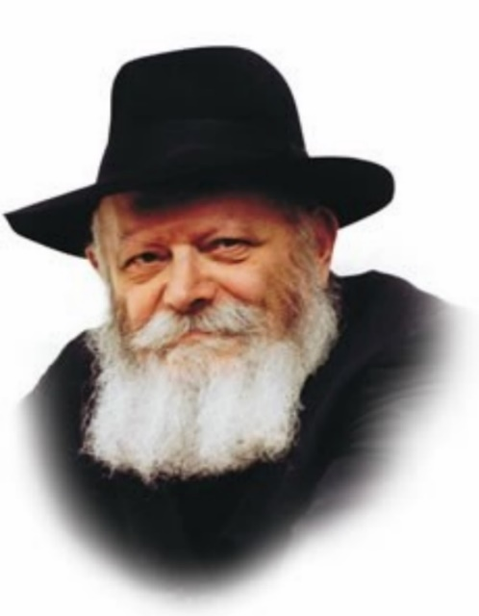

In this week's Torah portion, Chayei Sarah, we read of Sarah's passing, Abraham's purchase of the Cave of the Machpela in Hebron for her burial place, and Abraham's dispatching of his trusted servant Eliezer to find a wife for Isaac. All of these events took place when Abraham was at a well-advanced age. In fact, the Torah tells us, "And Abraham was old (zakein), well endowed with days."

The Midrash comments: "Some people are old but not endowed with days; others are endowed with days but not old. In this instance we find a person possessing both qualities."

What does this tell us about our forefather Abraham's greatness?

A zakein, an elderly person, is defined as one who has acquired wisdom. By studying Torah, he has learned a great deal. The zakein has achieved a high level of perfection of his soul.

"Endowed with days," however, refers to a person whose every day is perfect and whole. Not only does he perform the mitzvot properly, but he does so every single day of his life. Through his actions, the days themselves are elevated. He illuminates his environment by the commandments he observes and he raises his surroundings to a higher state of perfection.

The terms "old" and "endowed with days" refer to two types of people, and indeed, to two types of tzadikim. Some righteous people are concerned only with themselves and their own pursuit of excellence. By toiling greatly in the study of Torah they attain the level of zakein, but the people around them and the world at large are ignored. Time and effort are devoted solely to their own concerns.

Other tzadikim turn outward to disseminate their light upon their surroundings, devoting themselves to each and every person with whom they come in contact. These righteous people forget about themselves entirely, selflessly ignoring personal considerations for the sake of others.

Abraham, however, simultaneously embodied both of these qualities. "And Abraham was old, well endowed with days." While managing to achieve the highest level of personal perfection, Abraham sought to perfect his surroundings as well, thereby illuminating the entire world with holiness.

*Reprinted from the Parshat Chayei Sarah 5758/1998 edition of L’Chaim. Adapted from Likutei Sichot, Volume 3.*

**Thoughts that Count – Part II**

*And Abraham said to Eliezer, the eldest servant of his house who ruled over all he had..."Promise that you will not take a wife for my son from the daughters of Canaan." (Gen. 24:2)*

Eliezer's position and importance in Abraham's household is recorded for an important reason. When it came to financial matters, Abraham trusted many people. But when it came to spiritual matters, such as choosing a wife for his righteous son Isaac, Abraham would only send his most faithful servant, and even then Abraham made Eliezer promise to follow his instructions. *(Yalkut Hadrush)*

*And these are the years of Abraham, which he lived, 175 (Gen. 25:7)*

Abraham was destined to live until the age of 180. However, as his grandson Ishmael grew up his behavior became less appropriate. Knowing that Abraham would be greatly distressed by his grandson's behavior, G-d shortened Abraham's life by five years. The Torah includes the words "which he lived," to signify that these were the years he lived but they were not his full allocated lifespan. *(Yalkut Hadrush)*

*Reprinted from the Parshat Chayei Sarah 5758/1998 edition of L’Chaim. Adapted from Vedibarta Bam by Rabbi Moshe Bogomilsky*

**Rabbi Berel Wein on**

**Parshas Chayei Sara**

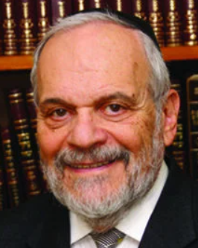

Our matriarchs of Israel were very strong personalities and were formidable women. The life experiences of our mother Sarah are an excellent example of this assessment of character and behavior. From the Torah narrative we are informed early on that she is infertile, unable to conceive and give birth naturally. Nevertheless, we do not hear despair from her. She is willing to bring another woman into her house and to share her husband, so to speak, with that woman in the hope that this would somehow facilitate her own becoming pregnant.

**Preserving the Primacy of Her Relationship with Avraham**

Having Hagar in her home and watching her arrogant behavior forces her to chastise Avraham’s attitude towards this complex relationship. She takes action to bring Hagar in line and thus preserve the primacy of her relationship to Avraham. Having escaped from the clutches of the Pharaoh and being aware of the dangers facing a beautiful woman in a cruel and violent society, she nonetheless continues her life’s mission of advancing monotheism and morality in a surrounding society that condones evil and violent paganism.

She is wondrously shocked, almost to disbelief, when informed by a stranger who appears as a Bedouin Arab that she will conceive and bear a son to Avraham. At that moment she realizes that she will not only become an “ordinary” mother but rather the matriarchal figure that will preside over an eternal people that will influence all future societies.

**A Woman of Iron that Acts for the**

**Future Survival of the Jewish People**

To protect and safeguard that eternity, she is forced to expel Yishamael from her home. She does not flinch at performing this distasteful task. In this respect, she is stronger than Avraham…and Heaven, so to speak, backs up her position. She is the woman of iron that acts to guarantee the future survival of the Jewish people.

Sarah serves as the paradigm for the matriarchs that follow her in the Torah narrative of the book of Bereshith. Rivka is certainly the strong force in the house of Yitzchak who recognizes the darkness of Eisav in comparison to the heavenly potential of Yaakov. She shows strength in having to do family triage, so to speak, and knowingly to accept the consequences of such a painful and agonizing decision. The ability and strength that she exhibits, in switching her husband’s blessings from the older son to the younger one, is indicative of the certainty of commitment and clarity of vision that so characterized all of the matriarchs of the people of Israel.

**An Example for the Subsequent Matriarchs**

Sarah lived on in Rivka and her life’s decisions. The same thing is true regarding Rachel and Leah who are more aware of the nefarious and dangerous ways of their father Lavan than is their husband Yaakov. It is they who finally force Yaakov to heed the Heavenly voice that directs him to leave Aram and return home to the Land of Israel.

Again, it is the strength of character and will that decides the ultimate issue, and it is that decision that tips the scales of eternity in favor of Jewish survival. If Chava is recorded as being the mother of all living things, it is Sarah who is the mother of the loving, vibrant and eternal people of Israel.

Shabbat shalom

*Reprinted from this week’s website of rabbiwein.com*

**Shabbos Circumcision.**

**By Rabbi Yehoshua Alt**

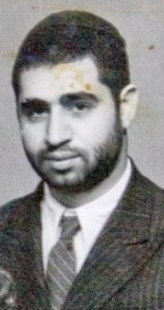

***Rabbi Ovadia Yosef, circa late 1940s***

In the year 1947 in Cairo, Egypt, R' Ovadia Yosef wrote: [Yabia Omer, volume 10, Yoreh Deah 25] “Here, in Egypt, the mohel is allowed to perform bris milah only by being certified by the health department. The Jewish population in Cairo is around 50,000 and at times there are several brisos (circumcisions) on Shabbos throughout the city.

[R' Ovadia Yosef resisted pressure put on him to study to qualify as a mohel when he was younger. Although the course of study was short, this skill would leave him running from one bris to the next. What would become of his Torah? In later years he expressed his satisfaction with this decision]

**Mohel Drives His Car on Shabbos**

The mohel in Cairo, who was the only one certified by the health department, drives in his car from bris to bris and therefore violates Shabbos publicly.” R' Ovadia was asked by some G-d fearing community members if they could employ this man as a mohel for their babies even though he didn't observe Shabbos or if they were obligated to travel to Alexandria, which was more than three hours away, where there were mohelim that were Shabbos observant.

R' Ovadia ruled that the circumcisions he performed were valid. However, he advised his students to travel to Alexandria where the bris would be performed by a fully observant Jew.

**Can a Mohel Circumcise**

**For Non-Jewish Arabs?**

“And for the bris of my son, Avraham, who was born in Egypt in 1949, I asked R' Maatuk Dhabi [R' Maatuk Dhabi once asked R' Ovadia Yosef a question that gives us a glimpse into the life of Jews living amongst the Arabs. He asked R' Ovadia if it was permissible to do circumcisions with milah and priah for Arabs as a paid job.

R' Ovadia replied that it is permissible to do it for Arabs and Christians even for free but one who refuses to do so "May he be Blessed" (Yabia Omer, volume 2, Yoreh Deah 19)] of the Alexandria rabbinate and he traveled to my house in Cairo from Alexandria and circumcised my son.”

**Baby Diagnosed with Jaundice**

[The evening before the bris, R' Maatuk arrived after a three-hour trip from Alexandria, only to diagnose the baby with a light case of jaundice. Together with R' Ovadia, he arranged to postpone the bris. When the baby was healthy, he returned from Alexandria to perform the bris.]

R' Ovadia then wrote, “I gathered my courage and spoke to this mohel who drove in order to circumcise. I spoke to him very gently and explained that he shouldn’t drive. I later heard that after I spoke to him, instead of driving himself if he needed to get to a distant circumcision on Shabbos, he hired a non-Jew to drive. I didn’t reprimand him for this.”

**Seeing Chilul Shabbos**

If a mohel was invited to perform a bris milah on Shabbos at a place where he may see Chillul Shabbos, what should he do? R’ Moshe Feinstein [Igros Moshe, Yoreh Deah, 1, 156] writes that even though it is forbidden to go to a place where they are transgressing Torah prohibitions, nevertheless since the mitzva of milah in its proper time is an obligation placed upon every Jew, the mohel is obligated to go and perform the bris—especially if there is no other mohel.

The Shulchan Aruch tells us that one is allowed to perform the needs for bris milah on Shabbos.[Orach Chaim 331:1] If it is known that because of the bris there will be Shabbos desecration, such as people driving to the bris, pictures being taken at the bris, and the like, what should be done?

**Concern that an Improper Mohel Might Perform the Circumcision**

The opinion of the Shevet Halevi [1:205,331. See 4:134-5. 9:210] is that although it is permitted on Shabbos to perform the bris of a child of those who desecrate Shabbos, it is still better to postpone it to Sunday. If this may cause an improper mohel to perform the bris, the Minchas Yitzchak [3:35] writes that the mohel is obligated to do it on Shabbos, since either way there will be Shabbos desecration, while deferring will only add to the already sub-optimal situation that the mitzva will not be done properly.

Another interesting question regarding a bris milah on Shabbos concerns a child whose 8th day does not fall out on Shabbos. For example, let’s say the child was born on Friday, yet they performed his bris nine days later on Shabbos. According to

halacha, a bris may only be performed on Shabbos if and only if Shabbos is the 8th day from the child’s birth.

In the example we cited, such a case is called a milah shelo b’zmanah (“circumcision not in its correct time”).[Orach Chaim 331:4] But the question arises what happens if it was nonetheless illegally performed on Shabbos? Is such a bris valid post facto or would the child need “another” bris in the form of drawing blood (hatafas dam bris), just as halacha calls for in a case where a non-Jew performed the milah? [Yoreh Deah, 264:1, Rema]

In a lengthy responsum about this question, R’ Akiva Eiger concludes the bris milah is still valid, and it is not even considered a mitzva habaa b’aveira (“mitzva which came through a sin”).[Shu”t R’ Akiva Eiger, Mahadura Kamma, 174] (Rabbi Y Alt - [yalt3285@gmail.com](mailto:yalt3285@gmail.com))

*Reprinted from the Parshat Vayeira 5783 parsha sheet whY I Matter edited R’ Yedidye Hirtenfeld for the Young Israel of Midwood.*

**Rav Aharon Kotler and the Fly**

**By Rabbi Reuven Semah**



Rabbi Yaakov Bender tells us a story that occurred with his parents that illustrates this very same point. One summer his parents were staying at a hotel in the Catskills. At mealtimes, they sat together with Rav Aharon Kotler and his Rebbetzin. At one point, a fly was buzzing around Rabbi Bender’s mother, and she waved it away. “No!” Rav Aharon said with distress. “No, do not swat it in that direction.”

           Mrs. Bender was puzzled, and the Rosh Yeshivah explained that she had swatted in the direction of the other guests, rather than towards the open door.

           That was it.

           We have never seen a fly take directions, but the Rosh Yeshivah was so sensitive that he was anguished at the thought that the fly might irritate others.

           “Limedcha.” That is what Rashi wants us to know. Great people take everything into account, and therein lies the secret to their greatness.

*Reprinted from the Parashat Lech Lecha 5783 email of Shabbat Shalom from Cyberspace.*

**A Trip to Panama Shifted How I View My Judaism**

**By [Shely Finberg](https://www.chabad.org/search/keyword_cdo/kid/31552/jewish/Finberg-Shely.htm" \o "Browse more articles by Finberg, Shely)**



According to conventional wisdom, you should “never say never.” But I’m a girl who said “never” a lot.

*Never going to conquer my fear of heights. Never going to give up on the Friday-night party scene. Never going to fly to a foreign country with a group of total strangers for Shabbat.*

(OK, I didn’t actually say that last one. But if you would have asked me a few years ago, “Would you fly to a foreign country with a group of total strangers for Shabbat?” I would have laughed in your face.)

Yet to my shock more than anyone’s, I just returned from a spontaneous trip to Panama where I explored an exotic country, bonded with strangers, and discovered the deep inner peace and satisfaction that comes from observing Shabbat.

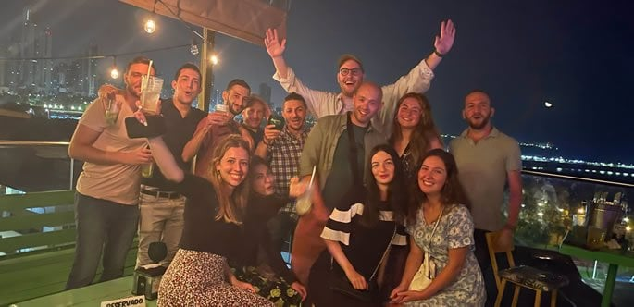

I might have to start rethinking all those “nevers” ...

But where are my manners? Introductions first. My name is Shely Finberg, and I am a nurse at Memorial Regional Hospital in Hollywood, Fla. Until quite recently, my knee-jerk reaction to organized religion was resistance. Perhaps my hostility was rooted in intergenerational trauma embedded in my DNA.

My parents and grandparents lived in the Soviet Union, where religion (the “opium of the masses”) was a federal crime. Although my parents immigrated to Israel before I was born, they never embraced a more Jewish way of life. Growing up in Ashdod, my knowledge of Judaism was scant to none.

When I was 11, my family moved to Brooklyn, N.Y. My parents decided to go to the synagogue in Manhattan Beach in an attempt to hold onto our Jewish identity in the United States—an identity we maintained by default in Israel. When we tried to enter the synagogue, a clerk asked us for a membership card. We didn’t have it, so they didn’t let us enter or join the services. We never attempted to go to synagogue again.

The experience left a bitter taste in my mouth, and my apathy towards Judaism morphed into antipathy.

Several years later, I became a student at the University of Buffalo. “Come with me to Shabbat dinner at Chabad,” my friend asked me.

“I’m not interested in being brainwashed,” I replied.

She continued pestering me week after week until I ran out of snarky comments. Finally, I surrendered. “I’m just going for the food,” I justified to myself.

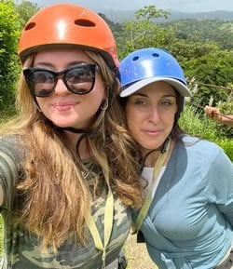

**With my rebbetzin, Rochel Holzkenner**

I came for the food but stayed for the company. The warm and welcoming Rabbi and Rebbetzin Gurary helped me feel instantly at home. Over the next three years, I joined every Friday-night meal at the Gurarys, literally trudging through snow and rain so as not to miss a single one.

After graduation, I moved to Florida and began working as a nurse. For the first time, I found myself without a campus or community to join. It was a fork in the road of my life, and I had to choose to go right or left: *Did I want Judaism to be a part of my life? Or was I perfectly content with my life as is?*

Making up my mind, I clicked on the tiny blue Facebook icon on my laptop and started searching for Jewish communities nearby. To my delight, I found [Chabad](https://www.chabad.org/library/article_cdo/aid/244369/jewish/About-Chabad-Lubavitch.htm) Young Professionals (CYP) in Las Olas, Fort Lauderdale, led by Rabbi Sholom Meir and Rebbetzin Rochel Holzkenner. I immediately fell in love with the relaxed and uplifting vibe of their tight-knit community.

One day, Rochel asked me if I wanted to join a Shabbaton in Panama organized by Chabad Young Professionals International. The old me would have said never, but the new me jumped in. A short time later, I booked a ticket and hopped on an airplane with more than 60 strangers to join “CYP Encounter: Panama.”

Actually, strangers is the wrong word. Although we each came from unique backgrounds, career paths and walks of life, we were united by a common identity. Whether American, Russian, Bucharian or Israeli-American like me, we were all part of one Jewish family. There is no deeper connection or kinship.

Something about coming to Panama inspired me to leave my comfort zone in more ways than one. On the first day, I went zip-lining in the Gamboa rainforest! The thrill and adrenaline of flying through the sky watching the lush greenery rush below me quickly overpowered my long-held fear of heights.

On Friday afternoon, while we were biking on a breathtaking trail, a new friend named Mark asked, “Are you excited for Shabbat?”

“Yeah, I’m so excited to meet the community,” I replied. (A key focus of the Shabbaton was for guests to

become acquainted with the vibrant Jewish community of Panama.)

“But are you gonna keep it?” he prodded.



“Hmm … ,” I said, stalling for time. I had never fully observed Shabbat in my life and wasn’t sure I wanted to.

“Shely, just do it!” he said.

Looking around at the beautiful scenery, I realized there was no better time or place for me to give Shabbat a try. I was surrounded by amazing company and had everything I needed to observe Shabbat. As Hillel the Elder once said, “If not now, when?”

“I’m going to do it,” I decided.

We finished the winding trail, went back to our hotel rooms and got ourselves ready for Shabbat. After lighting Shabbat candles, I made plans with some new friends to meet after our Shabbat dinners and attend a *farbrengen—*think crossover between an inspiring lecture and a cozy get-together with all your closest friends. It was actually the first time in my life that I made plans without relying on texting to communicate. We just chose a place and time and met there. (I know, I know, it’s revolutionary!)

That night, I joined a local Panamanian Jewish family for Shabbat dinner. They lived in a penthouse on the 45th floor of a skyscraper. The view outside the massive window was spectacular, but I was more entranced by the scene right in front of me: Parents and children talking to each other in a technology-free zone, truly listening and reveling in each other’s company. Over wine, challah and delicious homemade food, everyone shared what was on their mind and reflected on what they were grateful for.

*I want this,*I thought to myself. *I never had this growing up, but I want to give it to my own kids one day.*



Shabbat passed in a whirlwind. Thanks to the jam-packed schedule, I didn’t feel the impulse to reach for my phone even once. There were challenges, of course, such as not being able to walk through an automated electric door and having to make up words in Spanish for the workers to open them up. But all in all, I gained so much more from the weekend than I signed up for.

Ironically, it was hundreds of miles away from home that I discovered where I truly belong. I now realize how crucial it is to me to be a part of a Jewish community and surrounded by Jewish life. I now recognize that I want to find a life partner who shares my values. I now know that Shabbat is a gift from G‑d that can elevate my everyday existence. Most of all, I now realize that when I stop saying “never,” anything is possible.

*Interested in learning more about CYP Encounter? Go to:*[*ChabadYoung.com*](http://chabadyoung.com/)*. “CYP Encounter: Panama” is an initiative of Chabad Young Professionals International, a project of Merkos 302 at Chabad Headquarters.*

*Reprinted from this week’s website of Chabad.Org Magazine.*